**SOP for Arc + Cert server startup Procedure through Windows service**

**Servers:**

**Reston:**

10.44.33.25

**Chicago:**

10.46.33.25

Steps:

1: Search for Services once login to windows server

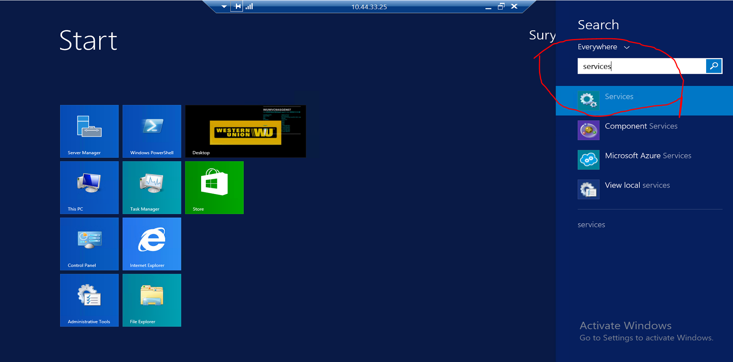

2: Search for **Jetty9service_env_Reston** in Reston and **Jetty9service_env_Chicago**, **I had removed all other duplicate jetty services to avoid confusion and to avoid startup of jetty6**

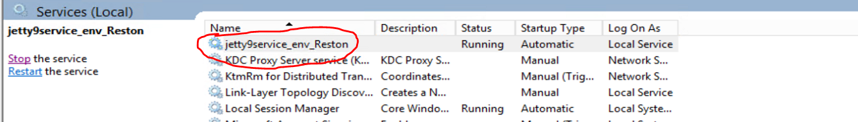

3. Stop and start are self explanatory. To Stop service click Stop in the left hand panel.

4. Start the Service by clicking Start through left hand panel .

5. **X509Server war file is under /E:/jetty-distribution-9.2.17.v20160517/webapps_wrapper/webapps/**

6. To Verify logs go to directory E:\jetty-distribution-9.2.17.v20160517\logs

i) jetty9service_env_reston-stderr.yyyy-mm-dd.log for detailed logging of startup log of jetty and detailed logging of certificate request.

Startup log Snippet:

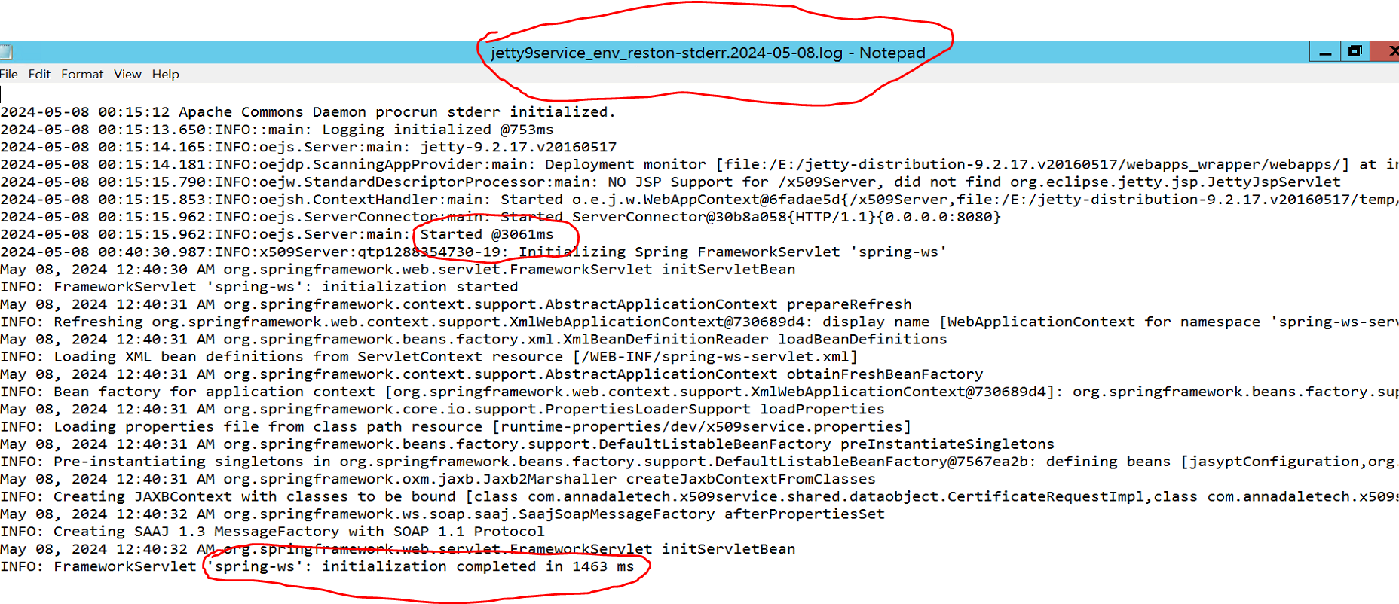

Certificate request Snippet:

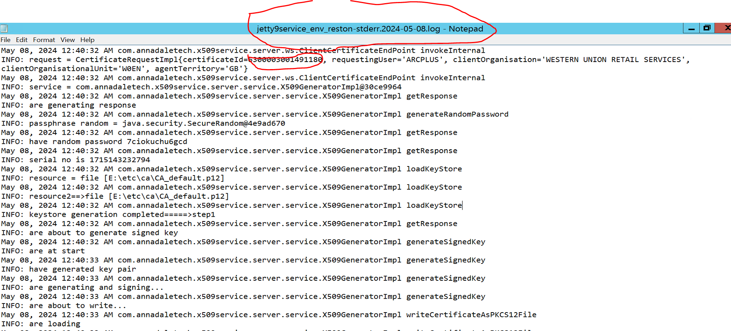

iii) For just info of the certificate requests we can check

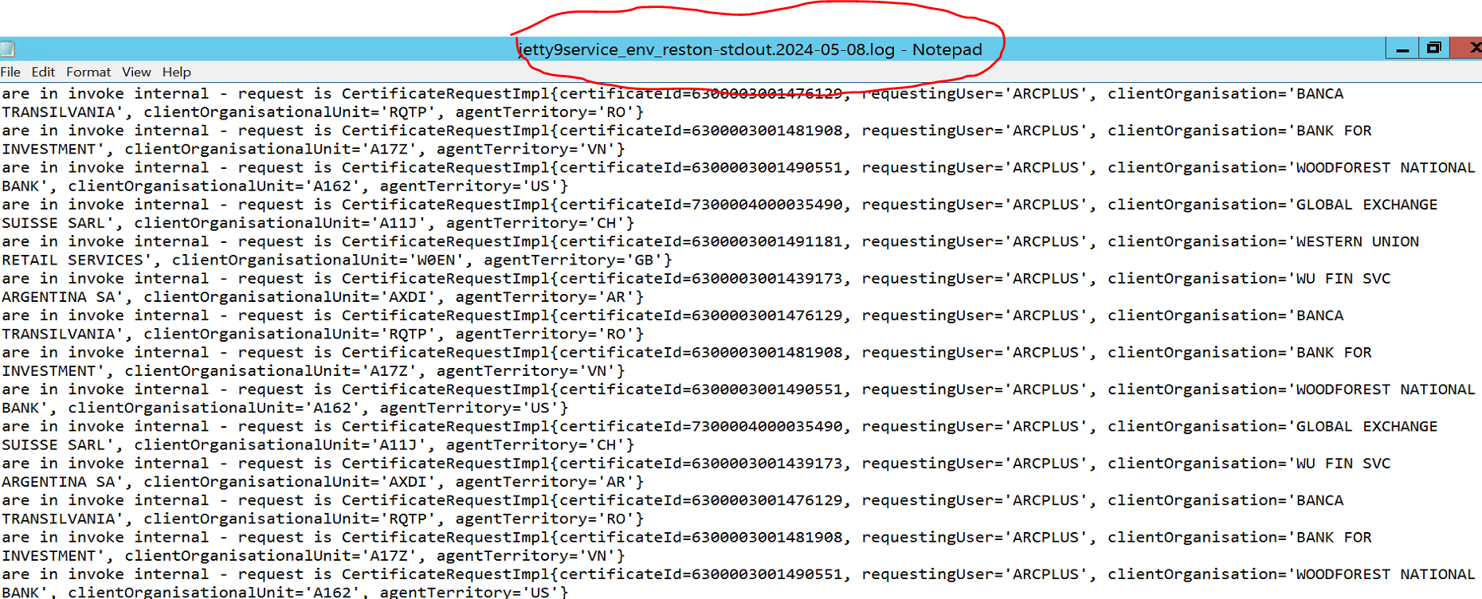

Important Note:

Highlights:

1. Windows Service is set to startup automatically when in case of windows server re-boot, we don’t need any Manual intervention which helps in recovering service in a matter of seconds post windows server re-boot
2. Logging is available “Now” for each and every cert request which is of re-issue or new request which is lacking earlier prior to this migration
3. At any point of time we can failover to command prompt startup process if at all incase of any issues with Windows services, it’s a matter of minutes to failover

Points to Remember:

1. As arc + works in active-passive setup , as of now Chicago is passive. If in case windows server re-booted in Chicago there might be a chance of auto startup of certificate server in Chicago, we need to manually stop the instance incase it auto-startups in passive DC
2. Never Delete or manual update below folders for the windows service to run smooth

**War location: /E:/jetty-distribution-9.2.17.v20160517/webapps_wrapper/webapps/**

**Logs location: /E:/jetty-distribution-9.2.17.v20160517/logs**

**Temp location for war file staging: /E:/jetty-distribution-9.2.17.v20160517/temp**

**Apache Procrun: /E:/Apacheprocrun**

Document prepared by SuryaNarayana Adusumalli